# Assignment 2 Cover Sheet



**BSc (Hons) in Information Technology**



**IT1060 – Software Process Modelling Semester 2 Year 01**

**Semester II- 2022**

|  |  |
| --- | --- |
| **PROJECT ID** | Y1S2_2023_MTR_G2 |
| **CASE STUDY NAME** | Dry Cleaning and Laundry Services |
| **CAMPUS/CENTER** | Matara Center |

**Group Details:**

|  |  |  |
| --- | --- | --- |
|  | **Student Registration Number** | **Student Name** |
| 1 | IT22253958 | W.P.R. Nethmina |
| 2 | IT22296078 | Sarithmal K.D |
| 3 | IT22226532 | D.V.D Hashan |
| 4 | IT22635952 | Abeywickrama A.S. |
| 5 | IT22244352 | Hewahalpage |
| 6 | IT22371522 | G.H.P Iroshan |



**BSc (Hons) in Information Technology**



# Assignment 2 Certify Sheet

**IT1060 – Software Process Modelling Semester 2 Year 01**

**Semester II- 2022**

|  |
| --- |
| We hereby certify,    Checkmark outline The attached is our own work and no further changes will be made.    Checkmark outline We have contributed in this assignment to the best of our ability.    And we understand,    Checkmark outline We may be subject to student discipline processes in the event of an act of academic misconduct by us including an act of plagiarism or cheating. |



**BSc (Hons) in Information Technology**



# Assignment 2 Certify Sheet

**IT1060 – Software Process Modelling Semester 2 Year 01**

**Semester II- 2022**

|  |  |  |  |  |
| --- | --- | --- | --- | --- |
|  | **Student Name** | **Student**  **Registration Number** | **Date** | **Signature** |
| **1** | W.P.R. Nethmina | IT22253958 | 26/09/2023 |  |
| **2** | Sarithmal K.D | IT22296078 | 26/09/2023 |  |
| **3** | D.V.D Hashan | IT22226532 | 26/09/2023 |  |
| **4** | Abeywickrama A.S. | IT22635952 | 26/09/2023 |  |
| **5** | Hewahalpage | IT22244352 | 26/09/2023 |  |
| **6** | G.H.P Iroshan | IT22371522 | 26/09/2023 |  |



**IT1060 – Software Process Modelling Semester 2 Year 01**



**BSc (Hons) in Information Technology**



**Semester II- 2022**

# It22253958 – W.P.R. Nethmina

# Part 1

# Use Case Scenario

|  |  |  |
| --- | --- | --- |
| **Number** | 6 | |
| **Name** | Collects customer feedback and ratings. | |
| **Summary** | Marketer collects customer feedback and ratings. | |
| **Priority** | 6 | |
| **Pre-condition** | Marketer has logged in to the system. | |
| **Post-Condition** | Marketer generates report. | |
| **Primary Actor** | Marketer | |
| **Trigger** | Marketer has chosen to analyze customer feedbacks and ratings. | |
| **Main Scenario** | **Step** | **Action** |
|  | 1 | Visit website |
|  | 2 | Enter username password |
|  | 3 | Validate username password |
|  | 4 | Collect feedback |
|  | 5 | Check ratings availability |
|  | 6 | Send thank you Email. |
|  | 7 | Enter ratings to the report |
|  | 8 | Analyze feedback. |
| **Extension** | **Step** | **Branching Action** |
|  | 3a | System notices login details are incorrect. Exists. |
|  | 3b | System Notifies invalid user. Exists. |
| **Open Issues** | 1 | Should the system classify ratings? |

# Part 1

# (2) Activity Diagram

# Part 2

# (1) Subsystems

# (a) Subsystems for Online Dry Cleaning and Laundry service.

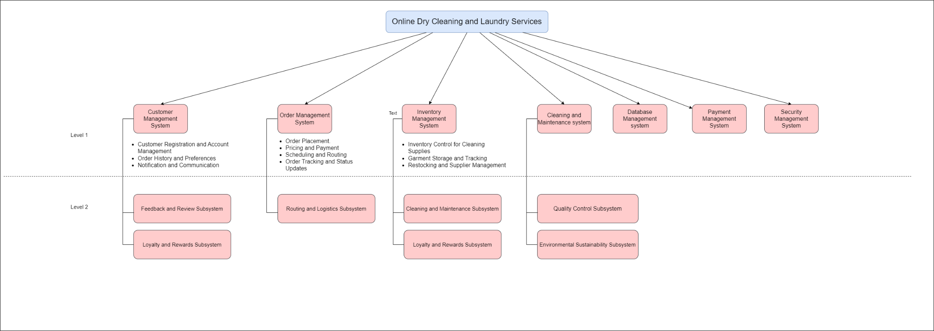

# (1)

# (b) Subsystems for “Collect Customer feedback and ratings” use case.

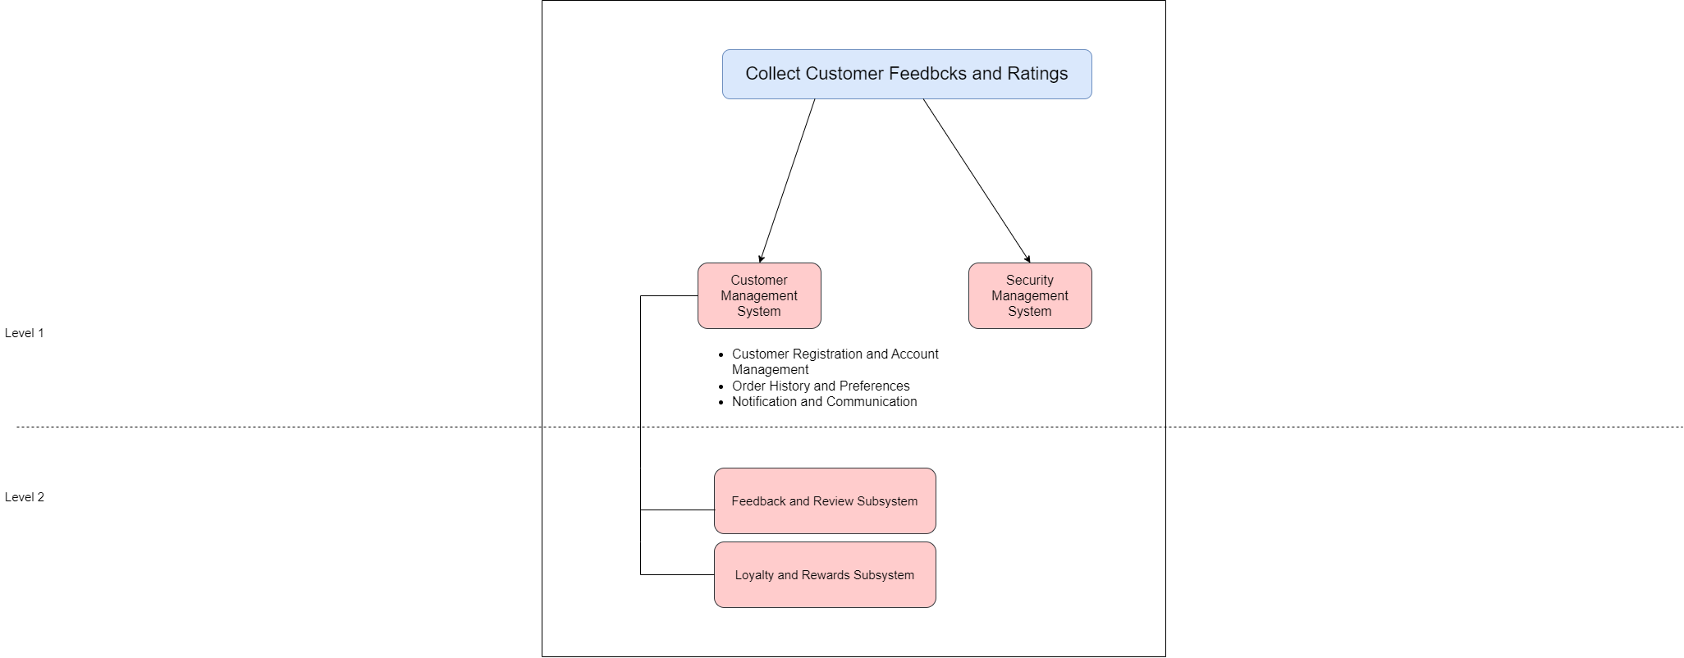

# Activity Diagram with Partitioning

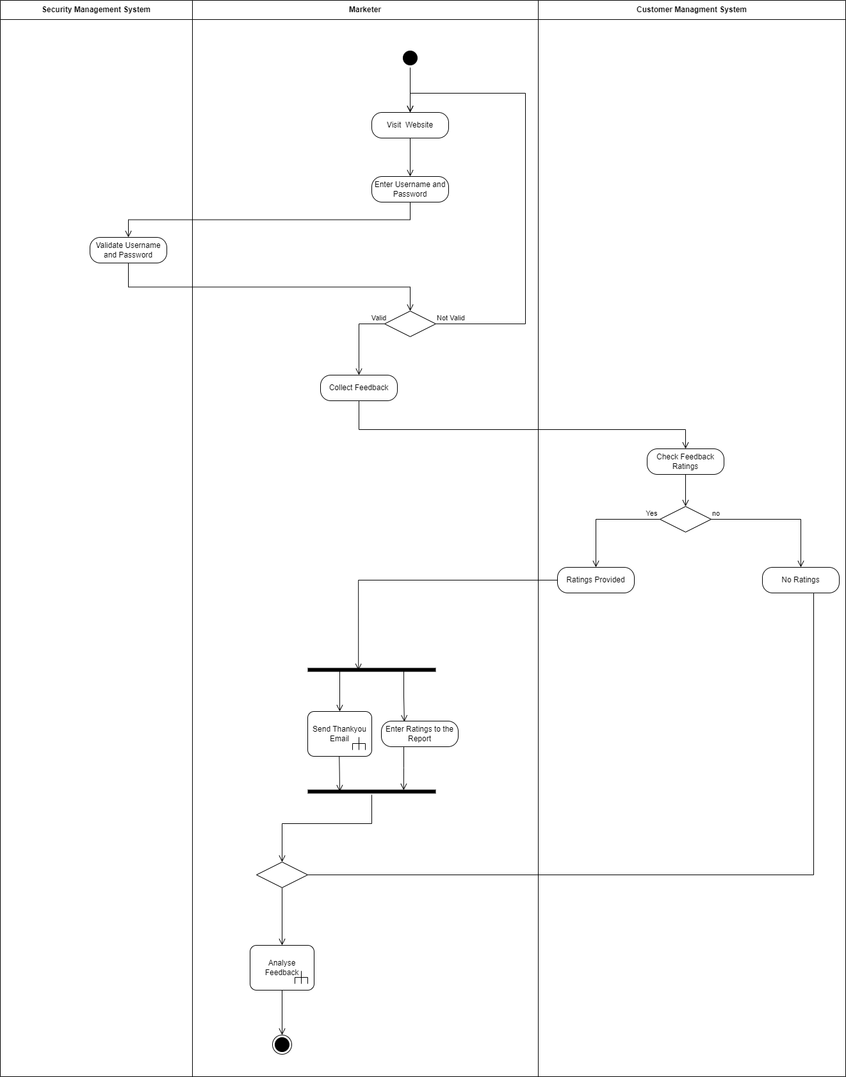



**IT1060 – Software Process Modelling Semester 2 Year 01**



**BSc (Hons) in Information Technology**



**Semester II- 2022**

# It22296078– Sarithmal K.D.

# Part 1

# Use Case Scenario

|  |  |  |
| --- | --- | --- |
| **Number** | 3 | |
| **Name** | Manage User Accounts | |
| **Summary** | Administrator Manages User Accounts | |
| **Priority** | 3 | |
| **Pre-condition** | Log into the Administrator Account | |
| **Post-Condition** | Log out of the system | |
| **Primary Actor** | Administrator | |
| **Trigger** | Admin has chosen to manage user Accounts | |
| **Main Scenario** | **Step** | **Action** |
|  | 1 | Visit the website |
|  | 2 | Login the system by admin credentials |
|  | 3 | User account management menu is displayed |
|  | 4 | Administrators select “create user accounts” |
|  | 5 | User details are entered |
|  | 6 | Save the user details |
|  | 7 | System creates new user accounts |
|  | 8 | System displays successful message |
|  | 9 | Administrators select “Update user accounts” |
|  | 10 | User details are entered |
|  | 11 | Administrator updates the user details |
|  | 12 | System updates the user account |
|  | 13 | System displays successful message |
|  | 14 | Administrators select “delete user accounts”. |
|  | 15 | System shows confirmation message |
|  | 16 | System deletes user account |
|  | 17 | System displays successful message |
|  | 18 | Administrator selects view user accounts |
|  | 19 | System retrieves user account information. |
|  | 20 | System displays user account information |
| **Extension** | **Step** | **Branching Action** |
|  | 2a | Admin Credentials are Wrong. Exists. |
| **Open Issues** | 1 | Should system Categorize User Account as paid customers and unpaid customers? |

# A diagram of a diagram Description automatically generated with medium confidencePart 1

# (2) Activity Diagram

# Part 2

# (1) Subsystems

# (a) Subsystems for Online Dry Cleaning and Laundry service.



**IT1060 – Software Process Modelling Semester 2 Year 01**



**BSc (Hons) in Information Technology**



**Semester II- 2022**

# IT22226532 : D.V.D. Hashan

# Part 1

# Use Case Scenario

|  |  |  |
| --- | --- | --- |
| **Number** | 4 | |
| **Name** | Cleaning Clothes. | |
| **Summary** | Fulfilment of the service as per the requirement of the customer | |
| **Priority** | 4 | |
| **Pre-condition** | Classify according to color and fabric. | |
| **Post-Condition** | Check whether fabrics are properly cleaned. | |
| **Primary Actor** | Dry Cleaner. | |
| **Trigger** | Dry Cleaner chooses to clean clothes | |
| **Main Scenario** | **Step** | **Action** |
|  | 1 | Login the website |
|  | 2 | Enter credentials |
|  | 3 | Enter OTP code. |
|  | 4 | Access dashboard. |
|  | 5 | Check Availability |
|  | 6 | Start washing Clothes. |
| **Extension** | **Step** | **Branching Action** |
|  | 1 | System will be display on error message |
| **Open Issues** | 1 | Should system categorize according to the service? |

# Part 1

# (2) Activity Diagram

# Part 2

# (1) Subsystems

# (a) Subsystems for Online Dry Cleaning and Laundry service.

# Activity Diagram with Partitioning

**IT1060 – Software Process Modelling Semester 2 Year 01**



**BSc (Hons) in Information Technology**



**Semester II- 2022**

# IT22635952 : Abewikrama A.S.

# Part 1

# Use Case Scenario

|  |  |  |
| --- | --- | --- |
| **Number** | 1 | |
| **Name** | Create Account | |
| **Summary** | Getting a service that matches the correct systematic payment amount | |
| **Priority** | 1 | |
| **Pre-condition** | Gather personal information | |
| **Post-Condition** | Receive a user ID | |
| **Primary Actor** | Registered User | |
| **Trigger** | User has chosen to view services | |
| **Main Scenario** | **Step** | **Action** |
|  | 1 | Visit the website |
|  | 2 | Head to the sign-up page. |
|  | 3 | Provide an acceptable username and email |
|  | 4 | Provide a strong password |
|  | 5 | Re-enter the password |
|  | 6 | Agree to the terms and reference |
|  | 7 | Click the sign-up button |
|  | 8 | Verify the Email |
|  | 9 | Fill the personal details. |
|  | 10 | Create account successfully |
| **Extension** | **Step** | **Branching Action** |
|  | 3a | If user enters an already existing username, let user enter a different username by notifying the user. |
|  | 4a | If a user enters a weak password, show an error message. |
|  | 5a | If a user re-enters a different password, prompt the user to re-enter the password |
| **Open Issues** | 1 | Should the System verify user is a human? |

# Part 1

# (2) Activity Diagram

# Part 2

# (1) Subsystems

# (a) Subsystems for Online Dry Cleaning and Laundry service.

# Activity Diagram with Partitioning

**IT1060 – Software Process Modelling Semester 2 Year 01**



**BSc (Hons) in Information Technology**



**Semester II- 2022**

# IT22244352 : Hewahalpage

# Part 1

# Use Case Scenario

|  |  |  |
| --- | --- | --- |
| **Number** | 2 | |
| **Name** | Manage Customer Payment | |
| **Summary** | Customer Payment Process | |
| **Priority** | 2 | |
| **Pre-condition** | The Customer Payment system is up and running. | |
| **Post-Condition** | Customer payments are successfully managed. | |
| **Primary Actor** | Manager | |
| **Trigger** | Manager has chosen to manage customer payments. | |
| **Main Scenario** | **Step** | **Action** |
|  | 1 | Login to the site as a manager. |
|  | 2 | Go to the payment list page. |
|  | 3 | If it is a complete payment, the date of completion of the payment and the payment ID should be shown. |
|  | 4 | View a list of orders with incomplete payments. |
|  | 5 | Check the payment |
|  | 6 | Payments are not confirmed for orders with incomplete payment. |
|  | 7 | The system displays the payment as verified and completed. |
|  | 8 | If the payment date is complete, it will be notified. |
|  | 9 | Initiation of notification if payment is incomplete. |
|  | 10 | The system sends an automated message or email to the customer. |
| **Extension** | **Step** | **Branching Action** |
|  | 6a | The system updates the payment status after the customer pays the dues. |
|  | 6b | The system shows the areas have been paid. |
| **Open Issues** | 1 | Should the payment period be extended to make customer payments? |

# Part 1

# (2) Activity Diagram

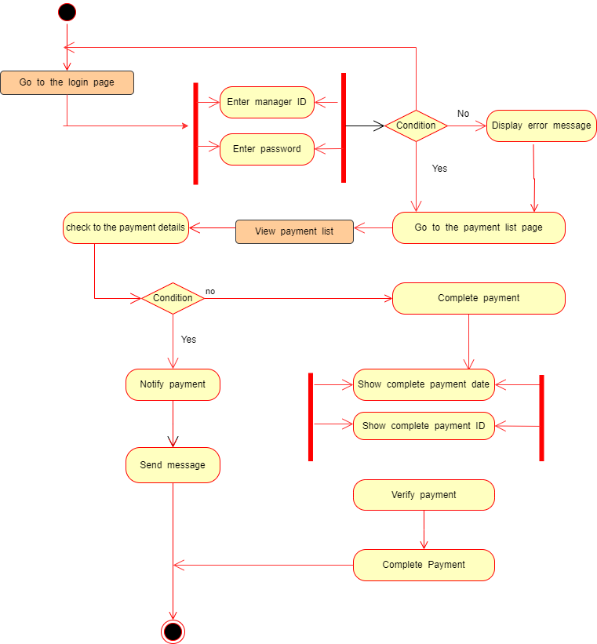

# Part 2

# (1) Subsystems

# (a) Subsystems for Online Dry Cleaning and Laundry service.

# Activity Diagram with Partitioning

**IT1060 – Software Process Modelling Semester 2 Year 01**



**BSc (Hons) in Information Technology**



**Semester II- 2022**

# IT22371522 : G.H.P.Iroshan

# Part 1

# Use Case Scenario

|  |  |  |
| --- | --- | --- |
| **Number** | 5 | |
| **Name** | check error | |
| **Summary** | check error of employee account | |
| **Priority** | 5 | |
| **Pre-condition** | manager should include monthly salary | |
| **Post-Condition** | An email and a message is sent to the employee and the company manager notifying that the employee has received the salary | |
| **Primary Actor** | Bank | |
| **Trigger** | User has to receive salary. | |
| **Main Scenario** | **Step** | **Action** |
|  | 1 | Get all employee saving accounts of the company |
|  | 2 | check salaries of each account holder. |
|  | 3 | Send a message to company and employee if his salary is not deposited to the savings account |
|  | 4 | If an employee asks for a check, it is returned as a check. |
| **Extension** | **Step** | **Branching Action** |
|  | 4a | User could be deposit and withdraw money in this account. |
|  | 3a | System notifies user that account funds are insufficient. |
|  | 1a | System gives current account balance. |
| **Open Issues** | 1 | should the system doesn’t allow receive money by ATM? |

# Part 1

# (2) Activity Diagram

# Part 2

# (1) Subsystems

# (a) Subsystems for Online Dry Cleaning and Laundry service.

# Activity Diagram with Partitioning

